Treasure Tampa 2019-20 Grant Cycle LOI
Gobioff Foundation

* Indicates a required field

Applicant Information

This section of the LOI is requesting information about the applicant which may or may not be the same as the 501(c)(3).

If the applicant is a 501(c)(3) then this information will be the same as the information entered during registration.
If the applicant is using a fiscal sponsor/agent then this information will be different than what was entered during registration and should not be the fiscal sponsor/agent information. In this case please do not provide the 501(c)(3) information, provide the organization information of the applicant.

Are you using a fiscal sponsor/agent?*
A fiscal sponsor/agent is a registered 501(c)(3) non-profit that is willing to accept money from The Gobioff Foundation on your behalf.

Choices
Yes No

Please enter the name of the organization that is applying.*
If the applicant is a 501(c)(3) then this information will be the same as the information entered during registration.

If the applicant is using a fiscal sponsor/agent then this information will be different than what was entered during registration. It is the applicant's organization (not the 501(c)(3) information).
Character Limit: 100

Please select the organization type of the applicant.*
If the applicant is a 501(c)(3) then this information will be the same as the information entered during registration.

If the applicant is using a fiscal sponsor/agent then this information will be different than what was entered during registration. It is the applicant's organization type (not the 501(c)(3) information).

Please select all that apply.

Choices Arts agency Arts group
Arts service organization Arts/cultural center Business/Arts Business/Non-Arts Community development Economic development Education
Festival Foundation Government
Individual artist/designer Institution of higher education Museum
Real estate developer Social Enterprise Venue
Other

If you selected "Other" as the applicant organization type, please enter an organization type.
Character Limit: 100

Project Information

This section requests information about the project. This is your opportunity to provide details regarding the creative placemaking project. Treasure Tampa is defining creative placemaking as the utilization of creative talent to elevate a community through cross-sector and community partnerships. The project must be new, not an already established festival, event, or installment.

What is the name of the project?*
Please enter a name for your project. (Maximum of 100 characters)
Character Limit: 100

Please provide a short description of the project.*
Use this space to give a one sentence description of the project. (Maximum of 250 characters).
Character Limit: 250

What is the expected start date of the project?*
Please enter the date you expect to begin implementation of the project. Note: Funding is for 12 months starting May 1st, 2020. Project must start within 6 months, by November 1st, 2020 and be completed by April 30th, 2021. Multi-stage or multi-year projects can continue past the completion date of April 30, 2021 but the launch of the project must happen by that date.
Character Limit: 10

What is the expected completion date of the project?*
Please enter the date you expect to complete the project. Note: Funding is for 12 months starting May 1st, 2020. Project must start within 6 months, by November 1st, 2020 and be completed by April 30th, 2021. Multi-stage or multi-year projects can continue past the completion date of April 30, 2021 but the launch of the project must happen by that date.
Character Limit: 10

Please describe your creative placemaking project.*
Use this space to give a detailed description of your creative placemaking project. This is your opportunity to explain your big idea. Paint us a picture that will help us to understand your vision and all that you are hoping to accomplish. (Maximum of 3,500 characters, approx. 500 words)
Character Limit: 3500

Provide a link to a video about your project.*
Please submit a link to a three minute video. The content of this video is up to you. It's your opportunity to highlight what you think are the most important things about the project in whatever way you choose. Quality of the video will NOT be judged, just the project info will be evaluated. Cell phone video of your projects lead showing their passion and excitement about the project is just fine!

- This video can be hosted on any external provider such as YouTube, Vimeo, Facebook, or any provider with which you are familiar.
- It is your responsibility to verify that the video works. There will be no follow up to confirm availability of the video.
- Reviewers will only look at the first THREE minutes of any video.

Character Limit: 2000

Please provide the password for the video, if appropriate.
If the video you have linked to is password protected, please provide the password here. (Max Length 20)
Character Limit: 20

If appropriate, submit one image to represent the artistic component of the project.
Upload in jpg, gif, or png format. Max file size 5 MB.
File Size Limit: 5 MB

Please provide a short bio for the primary person responsible for the artistic component.*
Please provide a short bio for the primary person (artistic director, curator, or artist) responsible for the artistic component of the project. (Maximum of 1,000 characters, approx. 150 words)
Character Limit: 1000

Collaboration

Treasure Tampa is requiring multi-sector collaboration. This section requests information about the partnerships that will be utilized to fulfill the project.

What is the best description of the project collaboration?*
Fiscal sponsors/agents should only be included in the description of collaboration if they are actively involved in the project.

Please select all that apply. A minimum of two should be selected.

Choices
Non-Profit
Private (For Profit) Public

Please describe the organizations involved.*
Please describe all of the organizations/partners involved and their roles with the project. Partner organizations are expected to have different leadership. For example, a non profit leader should not partner with their for profit business. (Maximum of 2,000 characters, approx. 290 words)
Character Limit: 2000

Community

The Treasure Tampa initiative is only for the geographic areas of the City of Tampa (check the address here) and the primary service area of the University Area Community Development Corporation. In addition, community involvement in the design, creation, or implementation of the project is required. This section is your opportunity to describe how you will involve the community impacted by the project.

Within which geographic area will the project be located?*
Please select one of the options.

Choices
City of Tampa
Area served by the UACDC

Please upload a map indicating the location of the project and the community to be impacted.*
If known, please identify the location(s) with a dot/pin/etc. and a circle around the impacted community on a map. It just needs to be a map with a circle (and a dot(s) if you have an address(es) for the project).

- This can be a screenshot of a google map, a photo of a printed map you wrote on, a sketch on a napkin, a pdf, whatever works for you.
- Reviewers will only look at the first page/image in this document
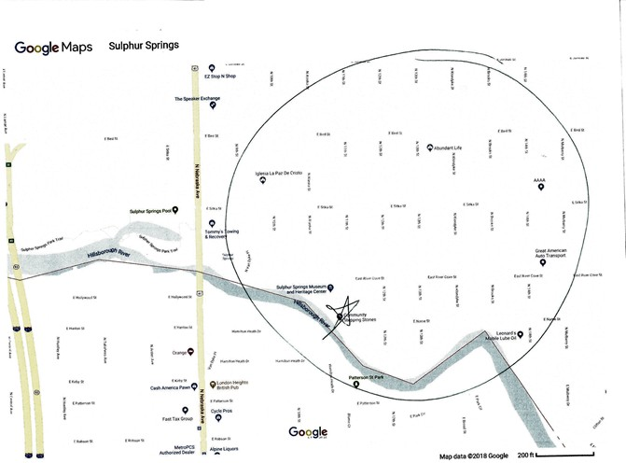
Example:
File Size Limit: 2 MB

Please describe the community.*
Describe the community being impacted and how this project will be beneficial to that community. (Maximum of 3,500 characters, approx. 500 words)
Character Limit: 3500

Please describe the community involvement aspect of the project.*
Who (person or group) are you involving from the impacted community and in what way
(design, creation, implementation, other)? (Maximum of 1,700 characters, approx. 250 words)
Character Limit: 1700

Funding

This section requests a brief amount of information about the funding for the project. Applicants that are invited to submit a full application will have the opportunity to provide more details at that time.

Note: Funding must be used between the start and completion dates of May 1, 2020 and April 30, 2021 with the exception of identified maintenance funds.

Identify the amount of funding you are requesting.*
What is the range of Treasure Tampa funding you are requesting?

Choices
Under 10,000
10,000 to 20,000
20,000 to 30,000

Please provide a general description of how the money will be used.*
In general how will the project use the grant money (at this time please do not submit a full budget) A rough percentage estimate of the how the money will be spent would be helpful? (Maximum of 1,700 characters, approx. 250 words)
Character Limit: 1700

Please describe any additional funding that might be used for the project.* Describe additional funding (secured or to be sought) that you need to complete the project. (Maximum of 1,700 characters, approx. 250 words)
Character Limit: 1700

