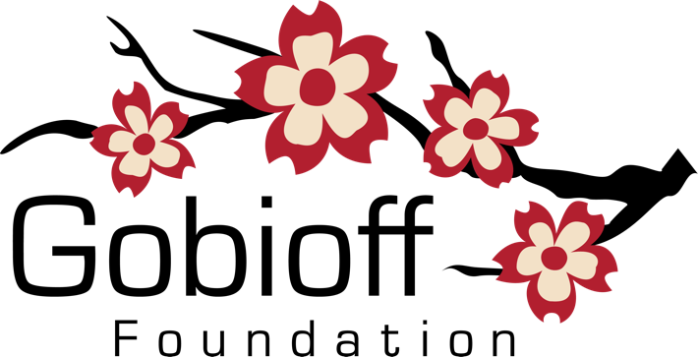
Microgrant Application

Gobioff Foundation
Contact us at grants@gobioff-foundation.org with any questions.

* Indicates a required field

Applicant Demographic Information
This section of the Application is requesting information about you, the applicant. We are collecting this information to understand what aspects of humanity the applicants represent. The information will assist with reaching equity in relation to future applicant recruitment.

This information will NOT influence the decision about funding. Notably, this information will not be shared with the panel of people making the decision about funding this project. The information will remain confidential and is required for the application to be considered complete.

Age*
What is your age?

Choices
Under 18 years
19-30 years
31-40 years
41-50 years
51 or more
Prefer not to say

Student Status*
Are you currently (or will be at the start of the project implementation) a student?

Choices
Yes, K-12
Yes, Undergraduate Yes, Graduate
Yes, Trade School or Apprenticeship
No

Gender Identity*
What is your gender identity?
Choices Woman Man
Trans/Non-Binary
Not Listed
Prefer not to say

Sexual Orientation*
What is your sexual orientation?
Choices Asexual Bisexual Gay
Heterosexual or Straight
Lesbian
Pansexual Queer Not Listed
Prefer not to say

Ethnicity*
What is your ethnic identity? (select all that apply)
Choices African Asian European
Latin(o/a/x)/Hispanic Middle Eastern
Native American/First Nations/Indigenous Pacific Islander
Not Listed
Prefer not to say

Race*
What is your racial identity? (select all that apply)

Choices
Black
Person of Color (who is not racially black)
White
Not Listed
Prefer not to say

Disability or Differently-abled*
Are you a person living with a disability or someone who is differently-abled?

Choices
No Yes
Prefer not to say

Project Information
This section requests information about the project. This is your opportunity to provide details regarding your project. The project must be new. Specifically, the grant funds must be used in some way towards a new public display/performance/exhibition/etc. (a project where the public has access to an event that has not started yet)

Project Name*
Name of Project.
Character Limit: 100

Type of Art*
Please select one category of art that best represents your project.

Choices
Visual (Painting, Drawing, Sculpting, Ceramics, Textiles, Printmaking, Film Making, Photography)
Performance (Dance, Music, Theater)
Creative Writing (Fiction, Drama, Poetry, Prose)
Assemblage
Installation

Date*
Please select the date you expect to start the project. In other words, the date that the project will begin to be available to the public. Note: The project is expected to start within six months of the notification of funding for this Cycle of the Microgrant program. Each cycle has a range of eligible dates for the project. Be sure you're applying during the correct cycle. Details about the dates can be found at www.gobioff-foundation.org/microgrants/
Character Limit: 10

Location1*
Please provide the name and a physical address (not a region) for the location where the project will occur. If the project is spanning an area or multiple spaces, please enter the location where the project will begin.

For example: Gallery XYZ, 123 Main St., Tampa, FL 33601 is acceptable. Starts at Park XYZ, 123 Main St. and travels North is also acceptable. But "In the Sulphur Springs neighborhood" is not acceptable.

Reminder: This funding is for projects within Hillsborough County, FL or Pinellas County, FL.
Character Limit: 250

Location1: Likelihood*
How likely is it that the project will occur at location1 provided?

Choices
Very Likely (location is aware of project, interested, and put event on their calendar)
Somewhat Likely (location is aware of project and interested but hasn't put event on their calendar)
Less Likely (location is not aware of project)

Location2
If you indicated "Somewhat Likely" or "Less Likely" for Location1, Please provide the name and a physical address (not a region) for a second location where the project might occur. If the project is spanning an area or multiple spaces, please enter the location where the project will begin.

For example: Gallery XYZ, 123 Main St., Tampa, FL 33601 is acceptable. Starts at Park XYZ, 123 Main st. and travels North is also acceptable. But "In the Sulphur Springs neighborhood" is not acceptable.

Reminder: This funding is for projects within Hillsborough County, FL or Pinellas County, FL.
Character Limit: 250

Location2: Likelihood
How likely is it that the project will occur at location2 provided?

Choices
Very Likely (location is aware of project, interested, and put event on their calendar)
Somewhat Likely (location is aware of project, interested, but hasn't put it on their calendar)
Less Likely (location is not aware of project)

Short Description*
Use this space to give a one sentence description of the project.
Character Limit: 250

Description*
Please describe the project. At a minimum we would like to know:
- What is the art that you will you be presenting?
  - Describe what you have created or will create and how it is unique/interesting/ambitious within the Tampa region and beyond.
- In what way will the public interact with or view the art?
  - Describe the setting and what will happen at the event(s).
- Who do you expect to participate or attend the project?
  - Describe the audience you hope to attract to your event with details such as quantity and demographics (Could include: age, student/non-student, gender, race, ethnicity, sexual orientation, local/non-local, etc.). This is your projection based on marketing, event location, artist affiliations (such as schools, community involvement, networks, social media, employment), etc.
Character Limit: 3500

Description (Optional Video)
Please provide a link (and password if necessary) to a three minute video. The content of this video is up to you. It's your opportunity to highlight what you think are the most important things about the project in whatever way you choose. The quality of the video will NOT be judged, just the information will be evaluated. Cell phone video of your passion and excitement about the project is just fine!
- This video can be hosted on any site such as YouTube, Vimeo, Facebook, or any provider with which you are familiar.
- It is your responsibility to verify that the video works. There will be no follow up to confirm availability of the video. Make sure the link works!
- Reviewers will only look at the first THREE minutes of any video.
Character Limit: 2000

Video Password
If needed, please enter the password for the video linked to above.
Character Limit: 250

Artist Information*
Please provide information about your artistic background, experience, and related education, etc. This should include information that you think will assist us in knowing who you are as an artist.
Character Limit: 2500

Artist Work*
Please provide example(s) of your previous work. Choose how you would like to share the example(s).
Choices
Upload a file Provide a link

Artist Work (Upload)

Artist Work Example(s)*
Please upload a file (jpg, png, gif, pdf, mp4, wav, mov, m4a, flac, mp3, aac, wma, wmv, avi, mkv) that shows us some of your existing or previous work.
File Size Limit: 5 MB

OR

Artist Work (Link)

Artist Work Example(s)*
Please provide a link to the work sample you would like to share. If linking to your web page, please provide a link directly to the work and not just to your entire website.
Character Limit: 2000

Artist Work Example(s): Password for Link
If the example linked to above requires a password, please provide it here.
Character Limit: 50

Resources
This section requests information about any resources you are working with and seeking to make the project happen. Many applicants will not have responses for all of these items because they don't relate to their project. Please complete the questions in this section that relate to your project.

Partners and Collaborators
Please list any partners or collaborators involved in this project and what they will be doing for this project.
Character Limit: 900

Gobioff Microgrant Funds*
Identify the amount of funding you are requesting. The maximum amount of money provided by the Microgrant program is $500. How much money is your project requesting?
Character Limit: 20

Other Funds
Are you seeking or have you already received money from other sources? If you are getting or hoping to get additional funding, please provide those details. What are those sources? How much are you receiving?
Character Limit: 500

Other Resources (non-funds/non-partners)
What resources do you already have or have you already acquired? What are the resources that you are providing? You should list out those things that you don't need to buy and don't need to get from someone else.
Character Limit: 900

Budget*
Please explain how you plan on spending the money. Here is a template to guide your answer - the template is available in pdf or xlsx.
File Size Limit: 1 MB

